**For more information, contact:**

Dan Danford, 262-636-7359

[dan.danford@caseih.com](mailto:dan.danford@caseih.com)

Claire Haupt, 262-424-6143

chaupt@bader-rutter.com

**Case IH Extends Its Track-Technology Leadership into Specialty Markets**



**With New Magnum™ Rowtrac™ Tractors**

RACINE, Wis. Aug. 26, 2014

Building on its 18 years of leadership in independent-track technology, Case IH has now introduced its new Magnum™ Rowtrac™ tractor. Two new models will be welcomed by any producer who has soil conditions that require better flotation and reduced compaction. A proven Case IH oscillating rear-track system is paired with front tire options to fit virtually any row width. This system keeps the power on the ground through the tightest turns, improves maneuverability, reduces berming and improves operator control of the tractor.

“Whether raising sugar beets in North Dakota, potatoes in Idaho or rice in the Delta, farmers will find our new Magnum Rowtrac meets their unique cropping needs through a wide variety of row spacing and belt options,” explained Zach Hetterick, Case IH Marketing Manager, High Horsepower Tractors. “And customers have told us that it outperforms other two-track options with better handling and a smoother ride. The flotation provided by the tracks allows them to get into the fields sooner since it avoids ruts and compaction, and doesn’t make divots when turning around.”

Hetterick notes that corn, soybean and wheat producers also will benefit from the improved flotation and weight distribution Magnum Rowtrac provides when pulling today’s increasingly wider, heavier equipment.

“Now that specialty crop producers have access to tractors with row spacings and tread widths adaptable to their cropping systems, they can put that extra flotation and efficient track technology to work on their farm,” Hetterick said. Row spacings on the Magnum Rowtrac can be set at 20, 22, 30, 34, 36, 38 or 40 inches. Narrow and wide undercarriage options give producers the ability to choose tracks in four widths: 16, 18, 24 or 30 inches.

“Timing is critical with high-value, specialty crops,” Hetterick said. “Our new Magnum Rowtrac tractors will help producers better manage wet conditions. Plus, these tractors are highly compatible with the specialty equipment used to grow these crops and have features, such as the CVT transmission, which can greatly increase productivity.”   
  
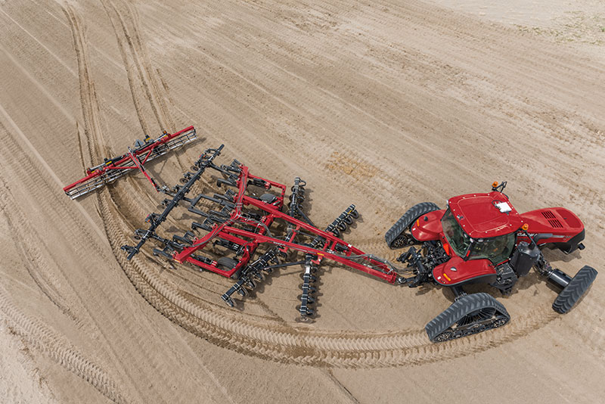  
Caption: The Magnum™ Rowtrac™ tractor completes the Case IH full line of equipment by providing a track tractor that’s fully adaptable to narrow or wide row spacing and has the maneuverability producers need.

Photo credit: Case IH

Click [[HERE]](http://www.caseih.com/en_us/PressRoom/Pages/Media-Library.aspx) to download a hi-res file.

**Power and performance**The new Magnum Rowtrac is available in two models: the 340 and the 380. Each features an 8.7-L engine that cranks either 340 or 380 horsepower. Both use patented Case IH Selective Catalytic Reduction (SCR)-only technology to meet Tier 4 B/Final emissions requirements and have proven to keep fuel and fluid costs low.

The operator-friendly Continuously Variable Transmission (CVT) comes standard on the Magnum Rowtrac 380. The popular CVT is optional on the Magnum Rowtrac 340 with tread spacing under 136 inches and standard with 136-inch tread spacing and above. Producers can opt for the Full Powershift transmission on the 340 when choosing a tread spacing less than 136 inches.

While flotation and traction are priorities for producers, it’s important to note they might not need to purchase the optional front duals for Magnum Rowtrac tractors.

“Flotation and traction are so good with the Magnum Rowtrac,” Hetterick said, “single wheels up front offer almost the same agronomic benefits as duals do.” Case IH will offer a redesigned front tire exclusive to the Magnum Rowtrac. The tire will feature a large footprint, further reducing soil compaction from the front end of the tractor.

**New, versatile axle**

With the Magnum Rowtrac, Case IH also introduces an optional front axle. Producers now can choose from among four front-axle options. The new Universal Wide front axle is 6 inches wider on each side than the standard axle. The Universal Wide axle offers ultimate versatility; it works with all row spacings and can be adjusted for all tread spacings. The Universal Wide axle and the standard axle are available as suspended or standard configurations.

**Legacy of track leadership**

This Magnum Rowtrac joins the Steiger® Quadtrac®, Steiger Rowtrac and Axial-Flow® tracked combines to deliver exceptional performance in independent-track technology. Hetterick cites other advantages over conventional mechanical front-wheel drive or track tractors:

* Full power in turns
* Reduced berms and minimal soil disturbance in wide or tight turns
* Four points of ground contact for increased flotation
* More traction, less compaction
* More power to the ground
* Earlier into the field to meet optimal planting dates

**Styled roof top, better lighting**

The Magnum Rowtrac tractors feature the new styled cab roof and new lighting packages, which also are used on Model Year 2015 Magnum wheeled tractors. The roof top brings a sleek new look and better positioned lighting for reduced eye strain when working into the night.

New lighting packages offer optional LED lights at different intensities, including a 360-degree LED setup for superior nighttime operation.

“The Magnum Rowtrac completes the Case IH full line of equipment by providing a track tractor that’s fully adaptable to narrow or wide row spacing and has the maneuverability producers need,” Hetterick said. “The Magnum Rowtrac delivers superior flotation and traction that provides benefits for the producer in all field operations, whether tilling, planting, seeding or harvesting.”

For more information about the new Magnum Rowtrac, contact your local Case IH dealer or visit [CaseIH.com/Magnum](http://caseih.com/en_us/Products/Tractors/Pages/magnum-farm-tractors.aspx).

Case IH is a global leader in agricultural equipment, committed to collaborating with its customers to develop the most powerful, productive, reliable equipment — designed to meet today’s agricultural challenges. With headquarters in the United States, Case IH has a network of dealers and distributors that operates in over 160 countries. Case IH provides agricultural equipment systems, flexible financial service offerings and parts and service support for professional farmers and commercial operators through a dedicated network of professional dealers and distributors. Productivity-enhancing products include tractors; combines and harvesters; hay and forage equipment; tillage tools; planting and seeding systems; sprayers and applicators; site-specific farming tools; and utility vehicles. Case IH is a brand of CNH Industrial N.V. (NYSE: CNHI / MI: CNHI).

###